**JEKZ - StepItUp User Manual**

StepItUp is a step-counting app that allows the user to record down their walked steps, see data collected, earn in-game currency, purchase accessories for their person in-app avatar as well as see their friends’ avatars.

**TABLE OF CONTENTS**:

1. Requirements
2. Installation
3. Using the app
   1. Login and Register
   2. Home Screen
   3. Friends List
   4. Shop
   5. Graphs
4. Requirements
   1. Android OS
      1. Android AP 19+ (Version 4.4+)
   2. Hardware requirements
      1. Touch Screen
      2. Accelerometer
      3. Online capability
5. Installation (Taken from Developer.Android.com)
   1. Connect your device to your development machine with a USB cable. If you're developing on Windows, you might need to [install the appropriate USB driver](https://developer.android.com/studio/run/oem-usb.html) for your device.
   2. Enable **USB debugging** in the **Developer options** as follows.
   3. First, you must enable the developer options:
      1. Open the **Settings** app.
      2. (Only on Android 8.0 or higher) Select **System**.
      3. Scroll to the bottom and select **About phone**.
      4. Scroll to the bottom and tap **Build number** 7 times.
      5. Return to the previous screen to find **Developer options** near the bottom.
   4. Open **Developer options**, and then scroll down to find and enable **USB debugging**.
   5. Run the app on your device as follows
      1. In Android Studio, click the **app** module in the **Project** window and then select **Run > Run** (or click **Run**  in the toolbar).
      2. In the **Select Deployment Target** window, select your device, and click **OK**.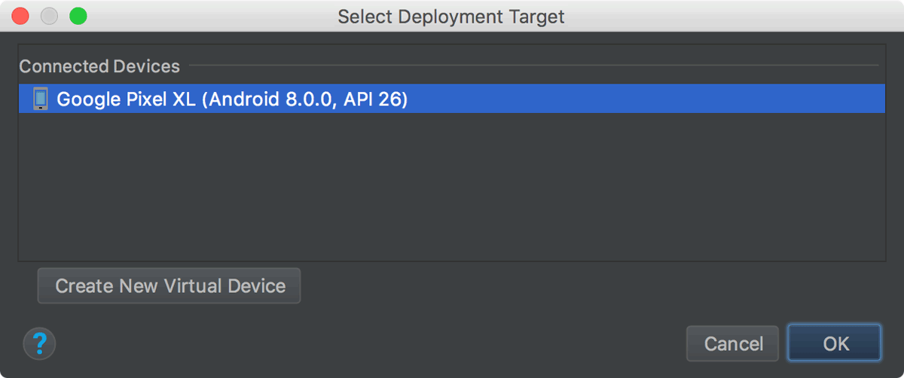
      3. Android Studio installs the app on your connected device and starts it.
6. Using the app
   1. Login and Register
      1. The login screen allows users to either login or register for an account. By default if the user is not logged in, the app will send the user to the Login page upon start-up where the user can log in or register.
      2. Logging In
         1. Login simply requires typing an account’s username and password before pressing the “Sign In” button to enter the home screen. As long as the user’s login session holds, the app will send the user to the home screen by default. If the session expires, the user will be required to login again.
      3. Registering
         1. Registering is very similar to logging in. In the login screen, there is an option to register if the user would like to create an account. The user simply has to choose a username and password of choice and press sign up. Using a username that is already taken will not work. Usernames are not case sensitive. A fresh account with default settings will be created upon success.
   2. Home Screen
      1. The home screen is the central page for the app, linking the various features togethers. The button icons display what features the user can use. Pressing the buttons in that toolbar will lead to the appropriate page. Centered on the screen is the user’s avatar. By default, the avatar will have nothing. This avatar can be changed and customized through the shop. The user’s login username and currency is displayed in the top half of the screen.
      2. The home screen also contains a step counter and a button to start walking sessions. The button will be used to start and stop walking sessions as the user. The step counter starts counting if a session is taking place. When a session is finished (up to the user’s choice), that session is stored and used for graphing data. Logging out in the middle of a session will end it as well.
   3. Profile
      1. The profile page holds data individual to the user like their height, weight and walking goals. It can be entered using the top right-most button in the Home Screen.
      2. The weight and height just need to be set once for full functionality of the graphing page. This is done by pressing on the category and either scrolling through the numbers or pressing on the number and typing a number in manually. Pressing Enter and then Save will save the user’s profile.
   4. Friends List 
      1. The user’s data is stored with their account, so all friend data will load up appropriately whenever the user is logged in with the app.
      2. The friends list allows users to search up friends to add to their friends list.
      3. Adding Friends
         1. Pressing the “Add Friend” button will load up a text box to type into. Search for users by inputting their usernames into this box. The search results will show up in the “Search” tab of the friend’s list.
         2. Press “request” to send a friend request to a user. If the other person accepts the friend request, the friend will show up in the “Friends” tab.
         3. All pending requests will show up in the “Pending” tab. There, you can choose to accept or decline their friend request with the “Confirm” or “Deny” buttons. Accepting will cause the person to show up in your “Friends” tab. In the case that both users send each other a friend request without accepting or denying the pending requests, the system will automatically treat the two users as friends and the pending request will disappear and the friend will show up in the “Friends” tab.
      4. Viewing Friends
         1. Friends can be viewed in the “Friends” tab
         2. Users can tap on their friends in the “Friends” tab to load up and view their friend’s avatar along with any accessories they have equipped on their avatar.
      5. Removing Friends
         1. All friends in the “Friends” tab will have a “Remove” button next to them. Pressing the “Remove” button will remove the friend from the friend’s list.
   5. Shop 
      1. The user’s data is stored with their account. Any owned accessories, equipped accessories and currency will load up appropriately whenever the user is logged in with the app.
      2. The shop allows users to customize their avatar by purchasing goods in the shop with currency earned from walking steps.
      3. The shop displays the user’s avatar on the top half of the screen.
      4. The player’s earned currency is displayed at the top right of the screen. Pressing the button above the avatar will change the avatar’s gender.
      5. Purchasing Items
         1. The shop itself has four tabs, one for each type of clothing that a user can purchase (Hats, Shirts, Pants, Shoes.) Press on a tab to display the items in each category.
         2. The user can scroll through all the accessories they can purchase. Pressing the “Buy” button next to an accessory will purchase it assuming there is enough currency to afford it.
      6. Equiping Items
         1. Upon purchase, the accessory will show up as owned and the “Buy” button changes to an “Equip” button. Pressing that will equip the accessory onto your avatar. Should the user not want to use that accessory anymore, they can equip another accessory of the same category to replace it or press the now “Unequip” button on whatever accessory is currently equipped. (The button swaps between “Equip” and “Unequip” accordingly.)
   6. Graphs 
      1. Upon loading the graph screen, the values for a user’s various lifetime averages are displayed in text and data for the past 7 days are displayed in charts. Scroll down and up to get the full view.
   7. Settings Screen
      1. Enter the user’s weight, height and daily step goal on this screen
      2. Choose between the metric and imperial systems for weight (kilograms or pounds) and height (centimeters or feet & inches)